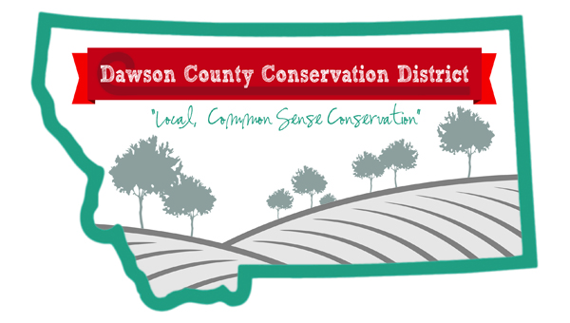
Dawson County Conservation District
102 Fir Street, Glendive, MT 59330
406-948-3173

“Local, Common-Sense Conservation”

Dawson County Community, June 9, 2026

Dawson County Conservation District will be holding a meeting June 18, 2026, at 7am at Yellowstone River Inn to adopt the Ordinance 2026-01 with the Notice of Intent & Land Use Regulations. The Ordinance passed in the June 2, 2026, election 1297 to 525. See Agenda below.

Agenda June 18, 2026

- Ordinance 2026-01
- Notice of Intent
- Land Use Regulations
- Public Comment

Thank you to all that voted for our Ordinance.
Sincerely,
Dawson County Conservation District
Supervisors & the Administrator

